Experiment worksheet

1.3 Scientists design their own experiments

Pages 8–9

Experiment 1.3A: Making a balloon rocket

Materials

• 1 balloon

• A long piece of string

• Sticky tape

• 1 plastic straw

• 1 tape measure

Method

1 Tie one end of the string to a chair.

2 Place the other end of the string through the straw.

3 Tie the loose end of the string to a second support so that the string is pulled tight.

4 Blow the balloon up and stick it to the straw. (Do not tie the end of the balloon.)

5 Measure the circumference of the balloon with the measuring tape.

6 Release the end of the balloon so that the straw slides along the string.

7 Measure how far the balloon rocket moved along the string.

8 Repeat this experiment twice more with the same balloon blown up the same amount. You now have a reproducible test for your balloon rocket.

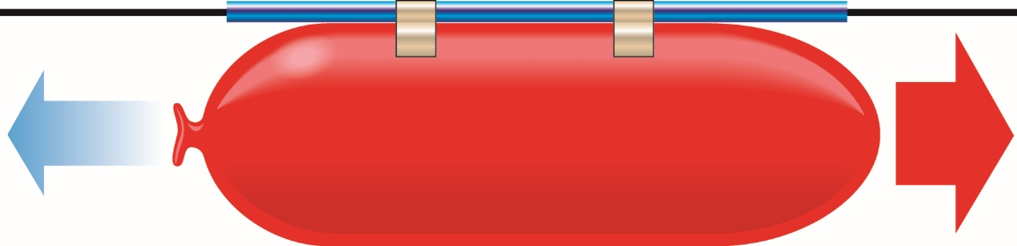

Figure 1When the balloon rocket is released, the straw will slide along the string.

Experiment worksheet

1.3 Scientists design their own experiments

Pages 8–9

Experiment 1.3B: Changing the independent variable

Aim

To determine factors that affect the distance a balloon rocket will travel.

Method

1 Choose one of the following questions to investigate.

• What if the balloon was blown up more?

• What if the string had less friction?

• What if the string had more friction?

• What if the straw was shorter?

2 Now, follow these steps.

• Write a hypothesis for your enquiry.

• What independent variable will you change from the first method?

• What dependent variable will you measure/observe?

• What variables will you need to control to ensure a fair test?

• How will you control them?

• Test your hypothesis. Repeat your test at least three times to make sure your results are reliable.

Results

Record your results in a table using the space provided. Include the units for all measurements.

|  |
| --- |
|  |

Discussion

1 Was your hypothesis supported? Use evidence from your results to support your answer.

2 Write a summary of your results.

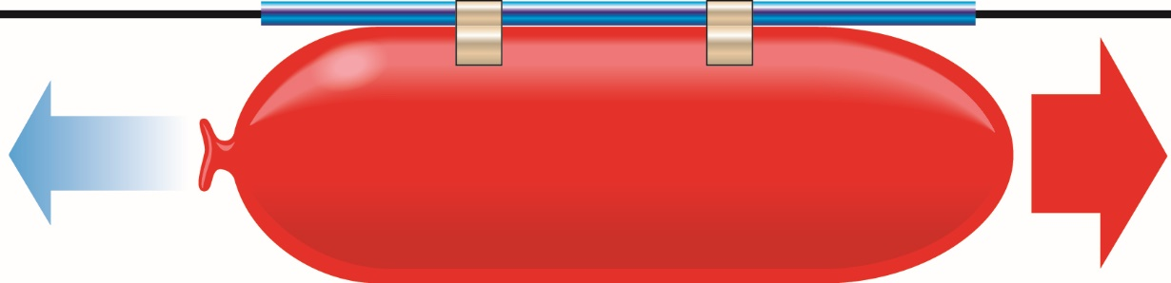

Figure 1When the balloon rocket is released, the straw will slide along the string.

Experiment worksheet

1.4 Scientists keep a logbook and write formal reports

Pages 10–11 and 159

Experiment 1.4: Marshmallow slingshots

Aim

To determine the relationship between the distance elastic is pulled back and the distance a marshmallow moves after it is released.

Materials

• Rubber bands

• Plastic ring or pipe cleaners

• Marshmallows

• Chair

Method

1 Make a chain of rubber bands by threading the end of one band through and over the end of the second band, then pulling tight.

2 Place a plastic ring in the centre of the rubber band chain.

3 Secure the rubber bands to the legs of an upside down chair as shown.

4 Insert a marshmallow into the ring.

5 Pull back the marshmallow the measured amount ensuring the elastic is horizontal to the ground.

6 Wait until everyone is out of the flight path, release the elastic bands.

7 Measure the distance the marshmallow travelled.

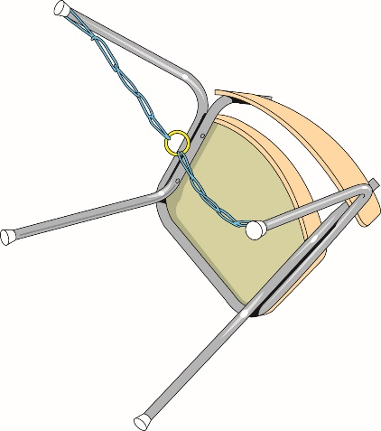

**FIGURE 1** Secure the chain to the legs of a chair

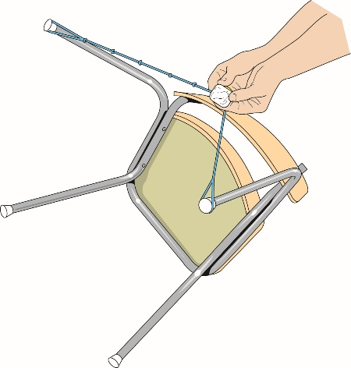

**FIGURE 2** Pull back the marshmallow the measured amount.

Inquiry: Choose one of the following questions to investigate.

• What if the elastic bands were not horizontal?

• What if the rubber bands were tied tighter?

• What if a smaller marshmallow was used?

Answer the following questions in relation to your inquiry.

• Write a hypothesis for your question.

• What (independent) variable will you change from the first method?

• What (dependent) variable will you measure/observe?

• Name three variables you will keep the same/control.

Record your method, observations and results in your logbook.

Results

Record your results and observations in a table using the space provided.

|  |
| --- |
|  |

Discussion

1 What was your independent variable? What was your dependent variable?

2 What variables were difficult to control? Explain how you overcame this difficulty.

3 Was your hypothesis supported? Use evidence from your results to support your answer.

Conclusion

What is the relationship between the distance elastic is pulled back and the distance a marshmallow moves?